Adam Mohmoud
AZ-900 Fundamentals
Two virtual machine’s Lab
Mohmoud.adam@gmail.com

In this lab I created a Virtual Network (VM), deploy two virtual machines onto that virtual network and then configure them to allow one virtual machine to ping the other within that virtual network.

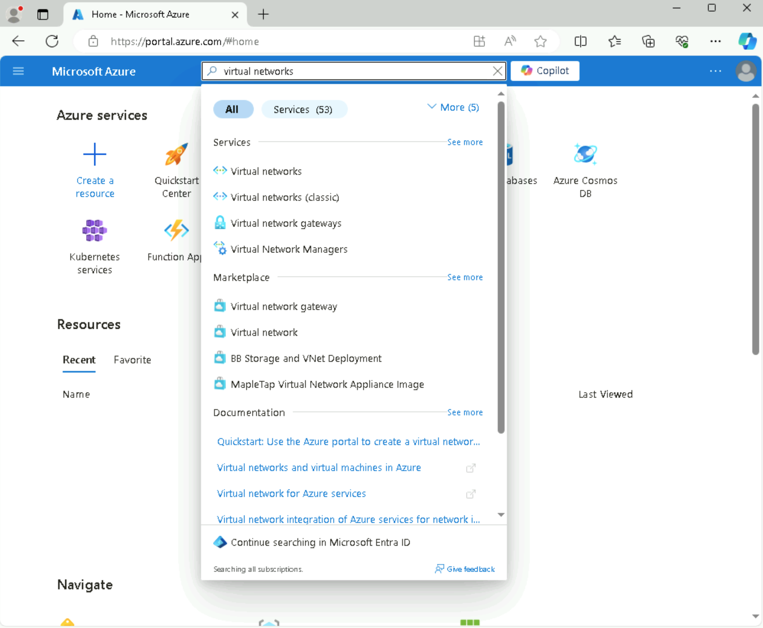
First thing I will do is on the Azure portal page is search resources, services, and docs (G+/) box at the top of the portal, enter Virtual networks, and then select Virtual networks under services.

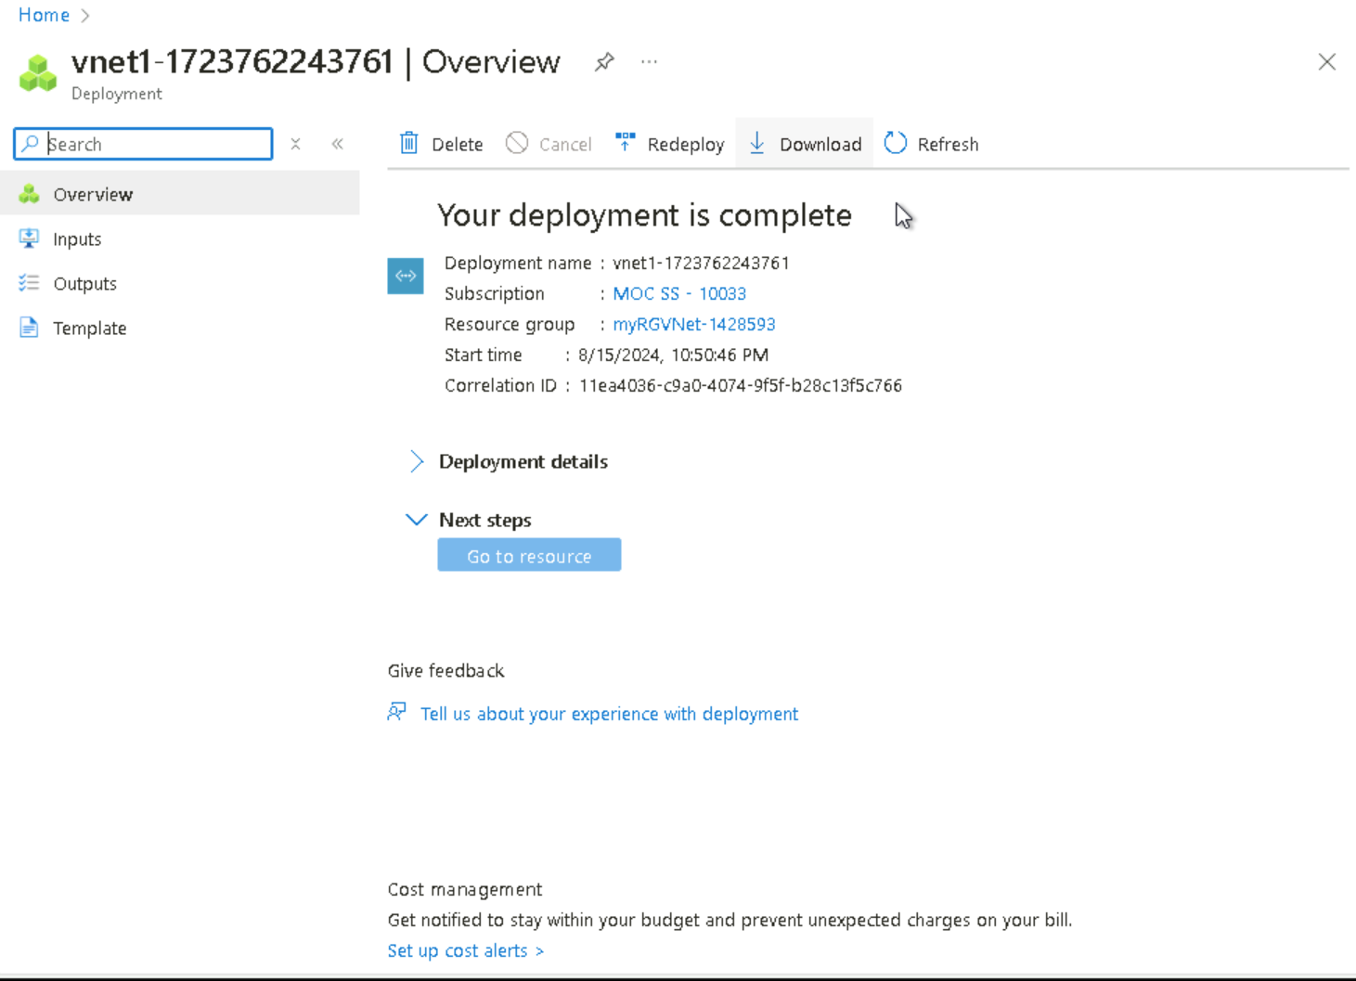
Virtual network created called “vnet1”

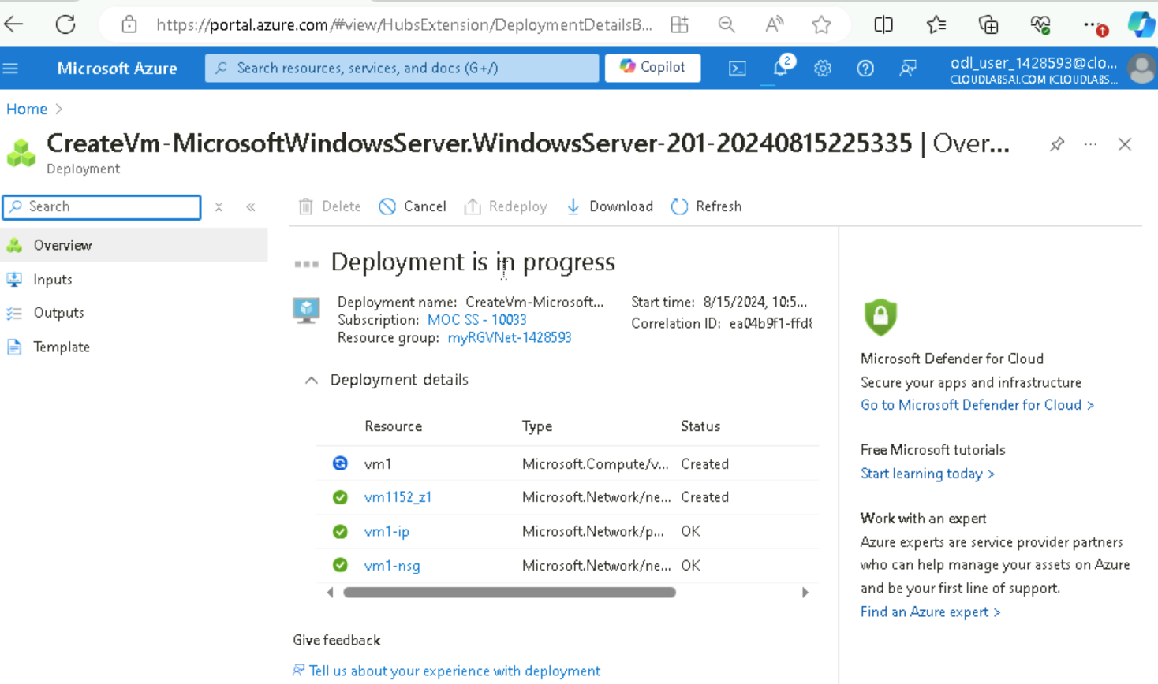
With the virtual machine in deployment, this suggests that the validation passed. This means that all the settings work well together and that I have permission to deploy this machine and have adhered to all the policies set forth by the organization for this virtual machine. This is “vm1”.
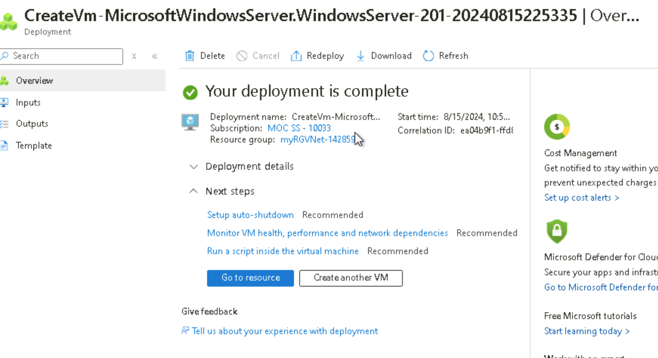
After the deployment has completed, I created an additional VM by clicking the tab “create another VM” repeating the similar steps as I did with creating “vm1”. This VM machine is called “vm2” built in the same virtual network (vnet1).

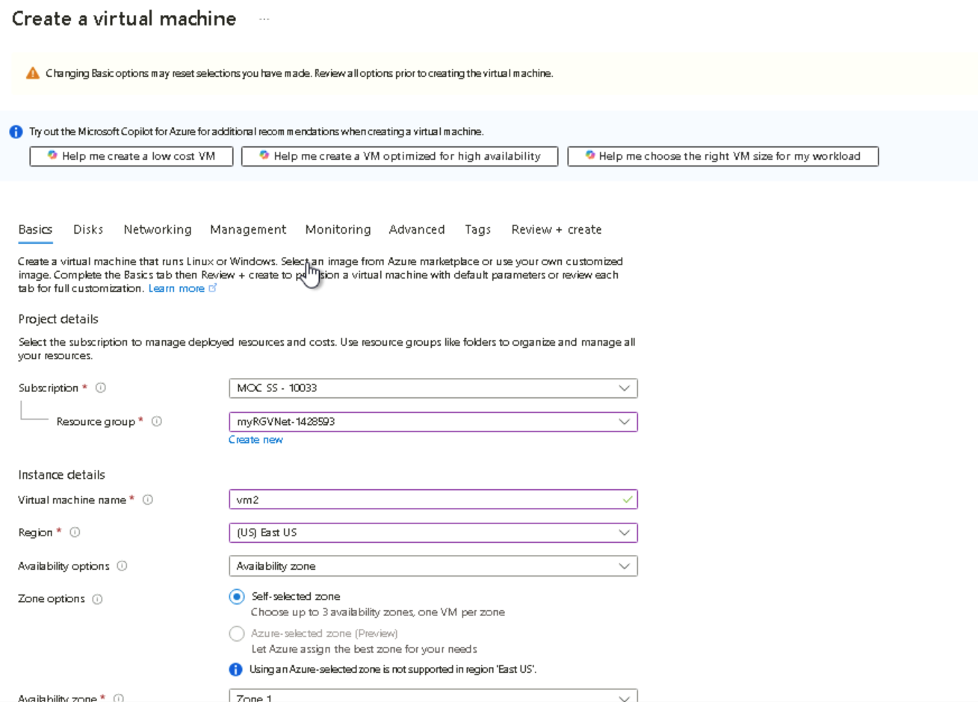
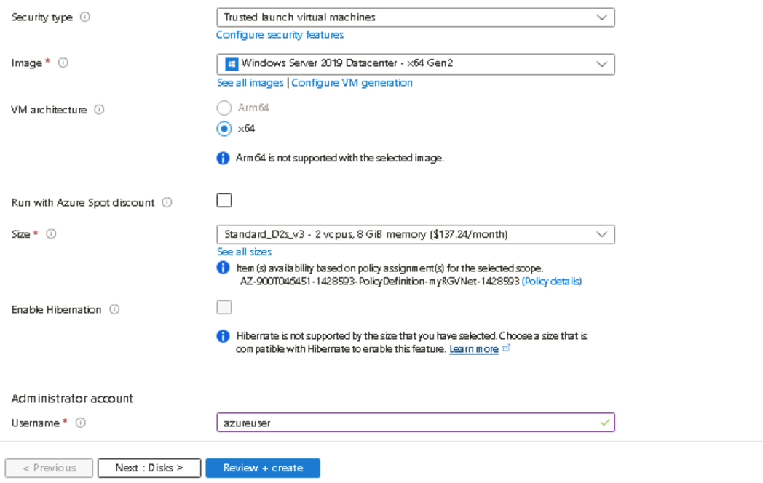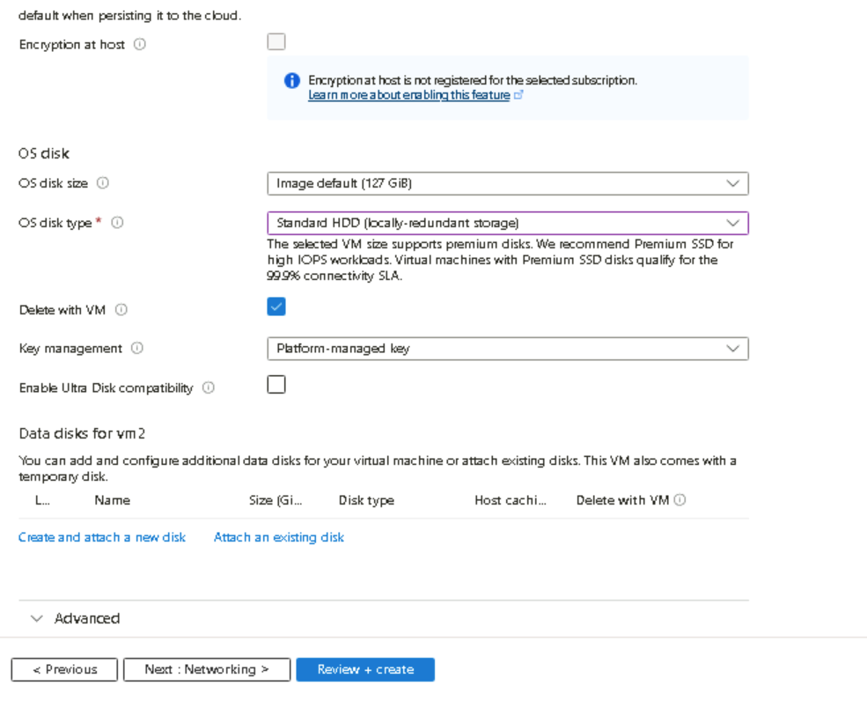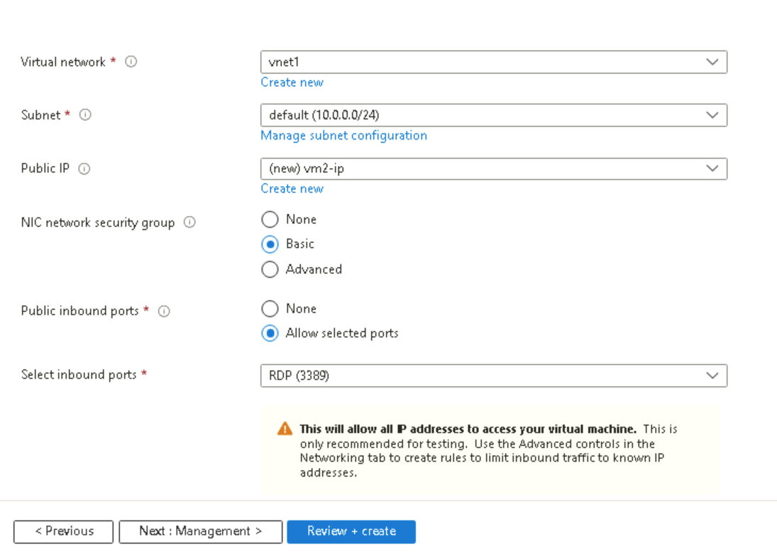
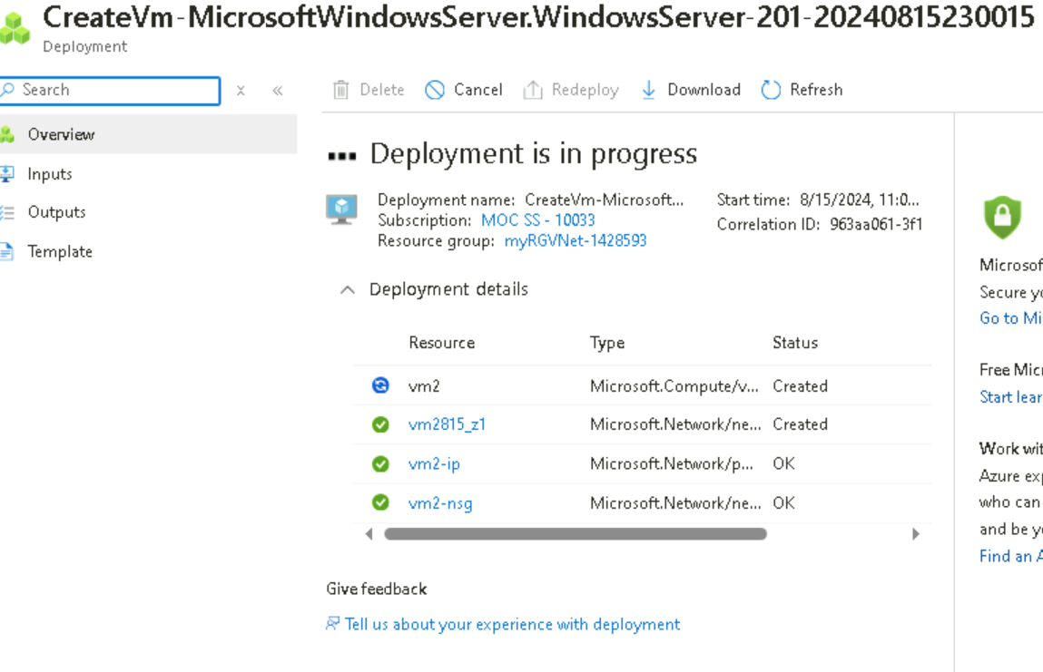
After validation passes and the VM machine “vm2” is deployed I continue to the ‘overview’ page. I proceeded to connect vm1 & vm2 then downloaded/connected using the RDP file on the local system.

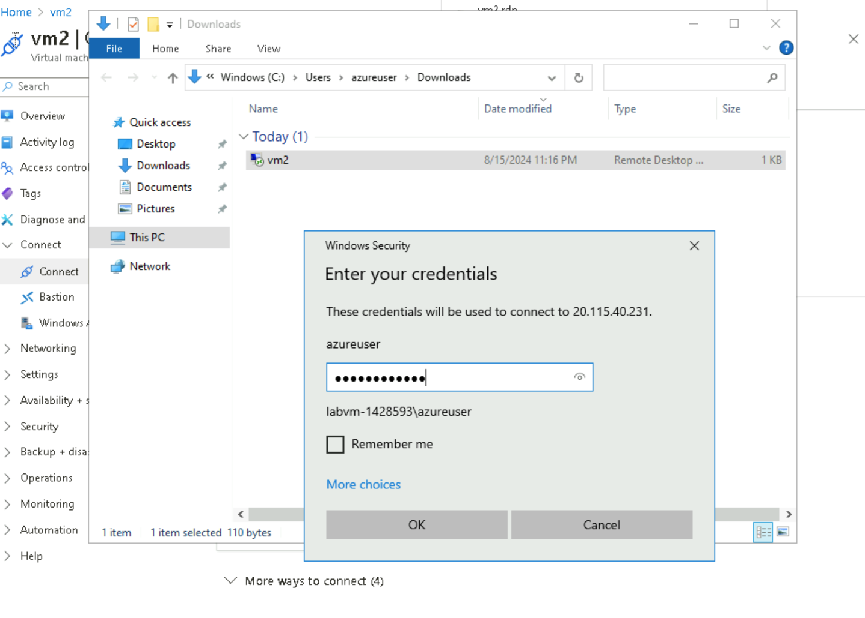
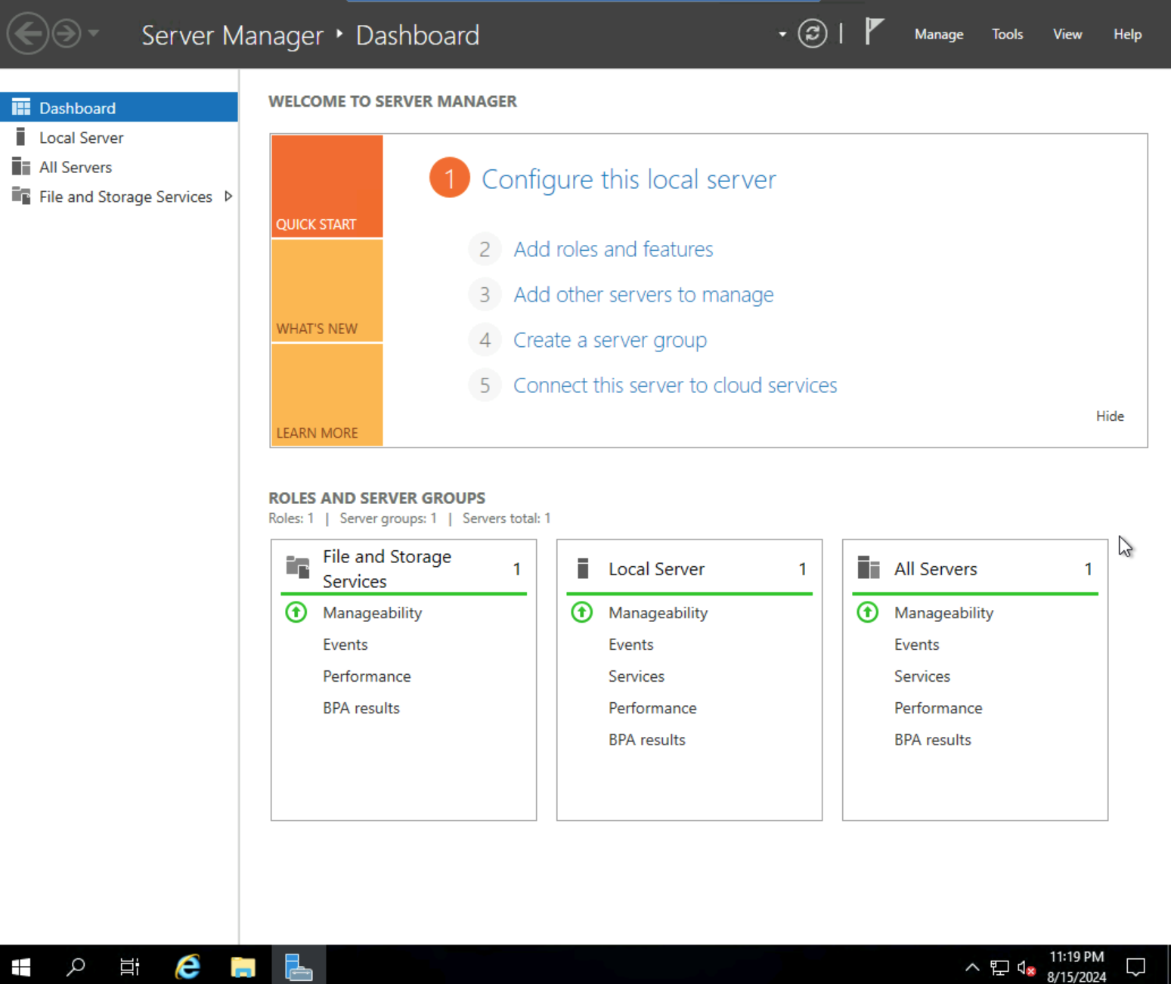

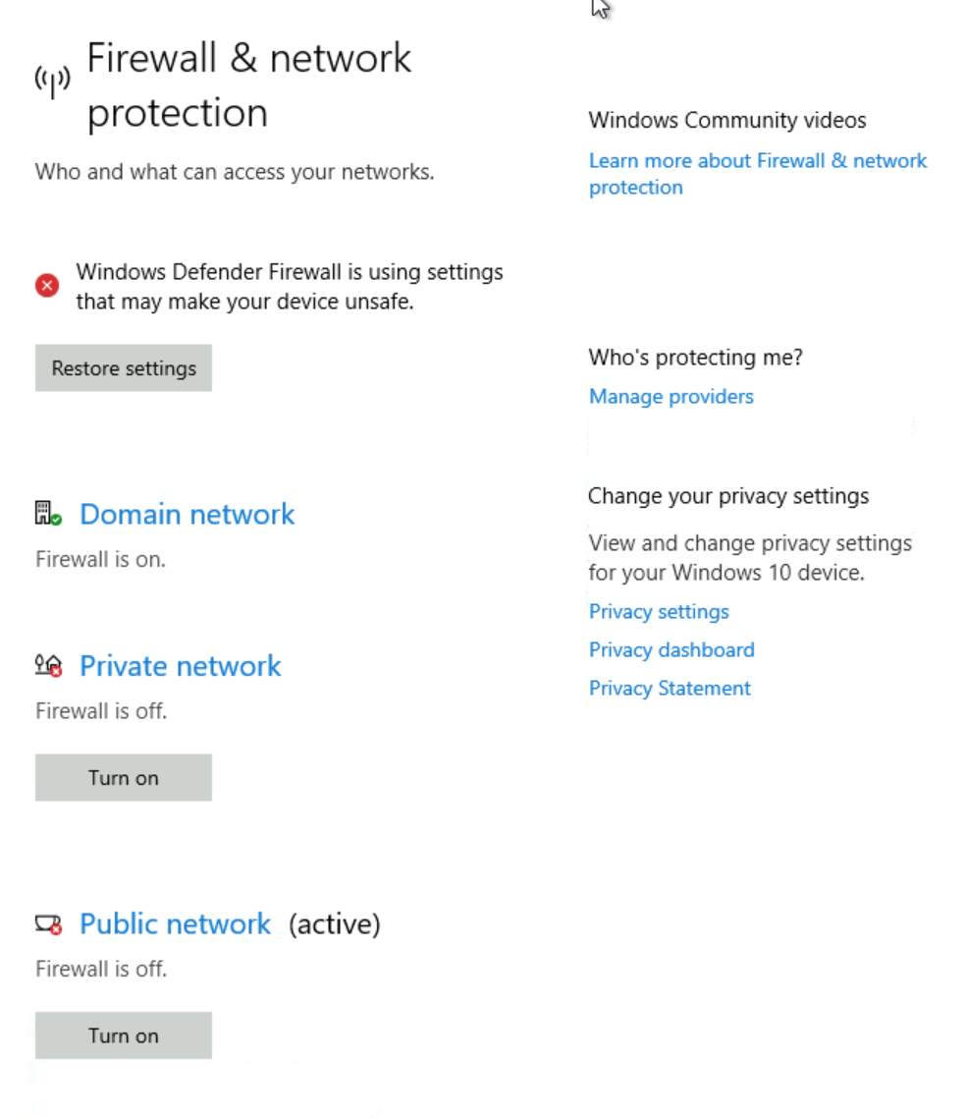
I disabled Private and Public network firewalls for both vm1 & vm2.
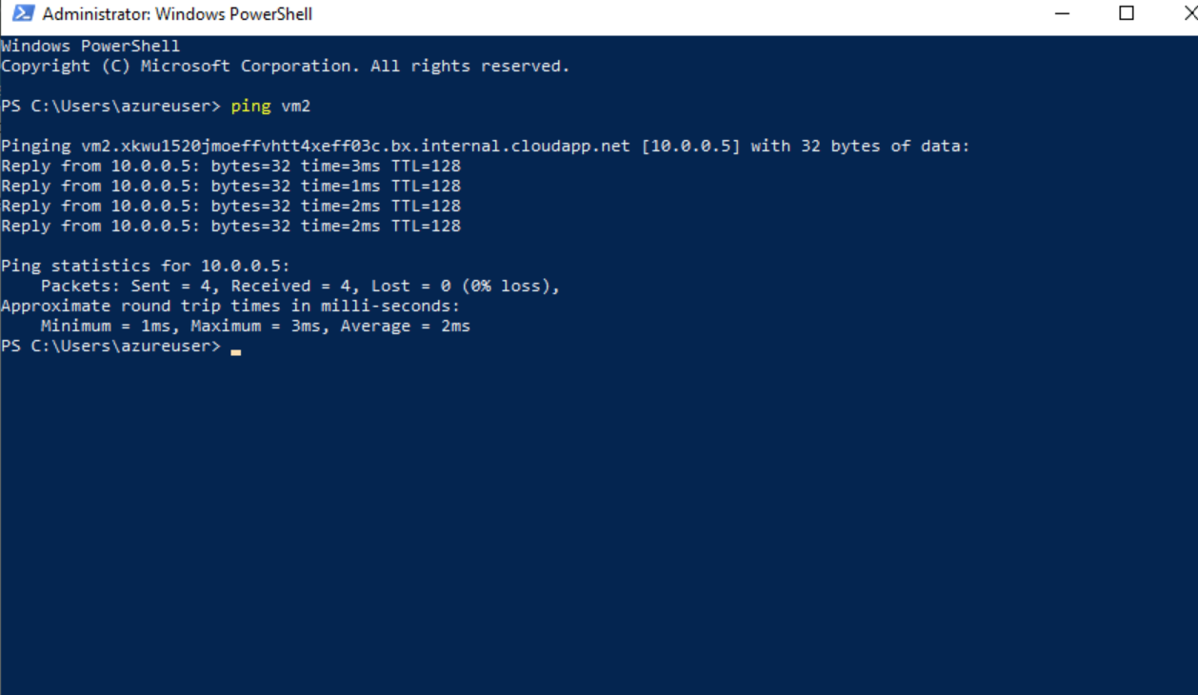
From the Windows Powershell command I successfully pinged vm2 from vm1. Confirming the two machines on one virtual network.
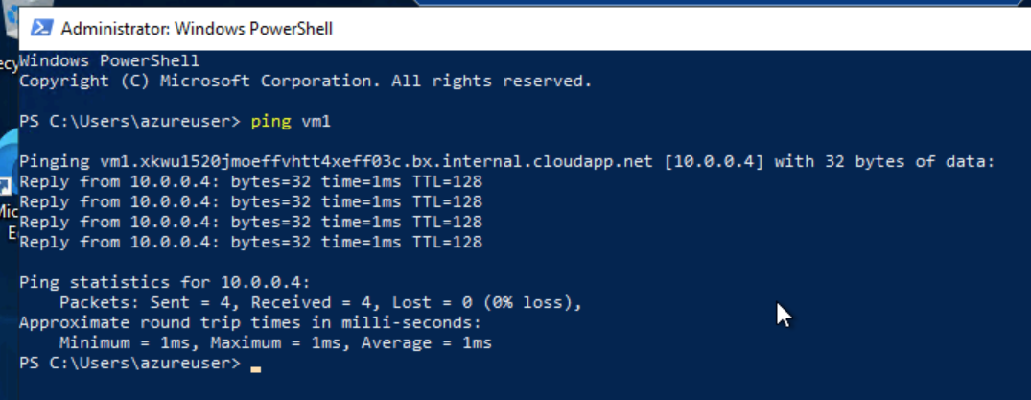
And vice versa pinged vm1 from vm2.



